Component Analysis

Year: 2024 Semester: Spring Team: 05 Project: Dodgebot

Creation Date: 02/01/2024 Last Modified: February 3, 2024

Member 1: Yusuf Jarada Email: yjarada@purdue.edu

Member 2: Ayman Motoda Email: aelnamr@purdue.edu

Member 3: Maximillian Drach Email: mdrach@purdue.edu

Member 4: Carlos Cotera Email: ccoteraj@purdue.edu

1.0 Component Analysis:

The major components we will cover will be crucial components of operation. The motors and drivers are a vital part to how responsive the robot is, and the motor drivers are a vital part in how complicated the motor controls will be to create. The camera is the second vital part of the robot since it determines how much information about the punches we get in the period that we set. The last one is about the microcontroller that we select since it will be responsible for the motor controls as well as the communication via UART to the main computer.

1.1 Analysis of Component 1:

Embedded sensors such as accelerometers and gyroscopes offer direct capture of motion data, facilitating precise tracking of movements. This movement data is highly accurate and monitors critical data about the direction of the punch. However, offloading sensor data to a remote computer has two non-ideal options: using a Bluetooth transmitter or data over wired cables. Bluetooth has a lower minimum latency of 20~30ms which is too slow of a time frame for a punch which reaches full extension at 100ms. [6] Sending the data over a cable introduces an extra cost to the user mobility experience when interacting with the Dodgebot (i.e. getting the way of the punch and dragging around).

Using a top-down camera allows us to use a faster frame rate of data that has lower latency. A MIPI-CSI2 Camera offers faster and high-resolution data transfer, but it can only send data for around 30 cm without signal degradation. [5] This means we would have to make sure the camera is close to the computer that is doing the image processing.

A USB 2.0 top-down camera presents a superior option for motion tracking compared to utilizing embedded sensors transmitting data over Bluetooth. With a frame rate of 260 fps, the camera ensures swift and precise tracking of movements. Its USB connection cable, boasting a latency of just 0.125 ms, facilitates rapid data transmission, resulting in faster updates and a continuous stream of high-quality frames. Additionally, the plug-and-play nature of USB cameras enhances ease of use and compatibility across various systems and platforms. Moreover, USB connections offer greater flexibility in terms of distance compared to MIPI-CSI2 interfaces, providing extended reach and versatility in deployment scenarios. These advantages underscore the efficiency of USB 2.0 top-down cameras for motion tracking applications.

Ultimately, we chose the USB 2.0 camera because of the ability to remotely interface with my more powerful component while still having low latency and easy to use for the end-user. We can easily plug and play with the camera over USB and don’t have to worry about where our processing unit is. This allows us to use my more powerful personal computer with a Nvidia 3060 instead of a Jetson Nano.

|  |  |  |  |
| --- | --- | --- | --- |
| **Component** | Embedded Boxing Glove Sensor [7] | USB 2.0 Top-Down Camera [3] | MIPI-CSI2 Top-Down Camera [4] |
| **Tracking Type** | Accelerometer & Gyroscope | Camera Color Tracking | Camera Color Tracking |
| **Communication Protocol** | 2.4GHz Bluetooth v2.0 | USB 2.0 | MIPI-CSI2 |
| **Refresh Rate** | ~30fps | ~260fps | ~206fps |
| **Max Distance** | >100m | >1m | ~30cm |
| **Location** | On Glove | Top-Down Bird’s Eye | Top-Down Bird’s Eye |
| **Power Source** | Battery | USB | MIPI |
| **Cost** | $166.50 | $68.30 | $15.00 |

1.2 Analysis of Component 2: Microcontroller

In the analysis of Component 2: Microcontroller, we evaluated two potential candidates, the STM32F207VG and the STM32F746ZG, for our DodgeBot project. Each microcontroller has its unique features, and the final choice is explained by the table below.

|  |  |  |
| --- | --- | --- |
| Criteria | STM32F207VG [1] | STM32F746ZG [2] |
| Clock Speed | Up to 120MHz | Up to 216MHz |
| RAM | 128kByte | 320kByte |
| Operating Voltage | 1.8 V to 3.6 V | 1.7 V to 3.6 V |
| Peak Current Consumption | 72mA (Run mode, full peripherals) | 235mA (Run mode, full peripherals) |
| UART IO Controllers | 3 (up to 10.5 Mbps) | 6 (up to 10.5 Mbps) |
| GPIO Pins | Up to 112 | Up to 168 |
| Timers | Up to 17 timers  – Up to twelve 16-bit and two 32-bit timers,  up to 120 MHz, each with up to four  IC/OC/PWM or pulse counter and  quadrature (incremental) encoder input | Up to 18 timers: up to thirteen 16-bit (1x low-  power 16-bit timer available in Stop mode) and  two 32-bit timers, each with up to 4  IC/OC/PWM or pulse counter and quadrature  (incremental) encoder input. All 15 timers  running up to 216 MHz, 2x watchdogs, SysTick  timer |
| Cost | $14.84 | $18.33 |

The STM32F207VG operates at a clock speed of up to 120MHz, which is only marginally lower than the STM32F746ZG. This microcontroller is also known for its lower power consumption compared to the STM32F746ZG. Although it has a slightly lower clock speed, the 100MHz required for the DodgeBot project is well within its capabilities. More importantly, the STM32F207VG may be more cost-effective, making it a suitable choice since we are already very tight on the budget at this stage of the project. Plus, while it may have fewer peripheral features compared to the STM32F746ZG, it offers sufficient capabilities for the Dodgebot project.

Conclusion:

The STM32F207VG emerges as a suitable choice for our DodgeBot project due to its adequate clock speed for the project requirements, lower power consumption, and potentially lower cost. Since the DodgeBot project may not demand the extensive peripheral features of the STM32F746ZG, the STM32F207VG strikes a balance between performance and power efficiency. Things such as the improved M7 ARM as opposed to M3 are irrelevant to our project. As for peripheral features, the STM32F207VG meets both our needs of being UART compatible needs and has much more than the ~20 pins we will require to control DodgeBot. At the same time, the more extensive features on the STM32F746ZG are nothing that we might need.

1.3 Analysis of Motor + Drivers:

The motor drivers and motors themselves for the purposes of this project come as a package for the feasibility of interfacing the system with our microcontroller so that we do not need to have a motor control card on our end of the system. We had a few design constraints to the power requirements that we needed for the motors based on the dynamics that were tested (see Appendix A). To create these speeds, we need motors of the following specifications:

|  |  |
| --- | --- |
| Specification | Value |
| Torque (X-Axis) | >= 28Nm |
| Torque (Y-Axis) | >= 40Nm |
| Weight (X-Axis) | <= 9kg |
| Voltage Supply | 110V – SP | 220V – SP | 220V – TP |
| Achievable Speed @ Torque | 600RPM |

For our breakdown, there were two main lines of motor systems that we looked at. The Kollmorgen AKM2G line and the Yaskawa SGD7G line of motors were the only ones on the market that offered both the motor as well as the motor driver that had built in motor interface commands. The specifications for the motors are shown below:

**Motor:**

|  |  |  |  |
| --- | --- | --- | --- |
| Specification | AKM2G-53L [9] | SGM7G-30A [8] | SGM7G-20A [8] |
| Torque (X-Axis) | 40Nm | x | 28.7Nm |
| Torque (Y-Axis) | 40Nm | 54Nm | x |
| Weight (X-Axis) | 8.89kg | 13.5kg | 8.6kg |
| Motor Face Width | 114mm | 180mm | 130mm |
| Achievable Speed @ Torque | 748RPM | 2000RPM | 2600RPM |
| Peak Current Draw | 37.6A | 70A | 42A |
| Price | $2394 | TBD | TBD |

**Driver:**

|  |  |  |
| --- | --- | --- |
| Specification | AKD2G-SPC-6V12S [9] | SGD7W-330A00A [8] |
| Communication Interface | CANBus | Analog Input/Output |
| Voltage Supply | 220V – SP | 220V – TP | 220V – TP |
| Peak Current Delivery | 30A | 84A |
| Price | $2220 | TBD |

Some main considerations for this project are the few differences there are between the motors and our application. The Kollmorgen motors do not need to be different from each other from each axis since their specifications were wide enough to fit both roles of the robot. The Yaskawa motors, however, required 2 different motors since the extra torque needed to meet the Y-Axis requirements resulted in over 5kg of added weight and 50mm of extra inertia that would need to be rotated. The resulting smaller motor has the torque needed, but it is also less than the Kollmorgen motor, but it is slightly lighter even though slightly bigger. With all these differences in specifications, the rotational dynamic data shows that either configuration will fit the performance characteristics needed for the robot to operate. One advantage to the Yaskawa motors is the speed characteristics. While we will probably never reach the speeds that the motors can operate it, it does give us additional options to gear down if we need to, based on the speed of the prototyped motor. The Kollmorgen motors do not have any room to gear since they are just barely above the rotational speed requirements. The biggest difference will be the current requirement for the motors and shows the biggest difference in technology. The Kollmorgen motors are based on a BLDC design which uses permanent magnets to operate. The Yaskawa motors are AC motors which require fewer complex controls to operate and are typically cheaper technology to produce, but they require much more power for the equivalent torque values. Even though the Yaskawa motors draw more current, both motors require 220V power whether it be single phase or three phase power to operate. The communication interface for the Kollmorgen motors is ran off CANBus which is a robust communication interface that doesn’t require any special circuitry to communication besides the connector between the microcontroller, and specifically placed resistors along the network. This does require more software involvement in sending motor commands as well as reception techniques of the microcontroller to read and send data quickly. The Yaskawa motors rely fully from analog signals which does require line drivers to send and receive signals, but they are much easier to diagnose, read, and create preconfigured commands to send to the motor controller from simple power electronics techniques. The final detail in the comparison is the price. The Kollmorgen motors totaled to over $10000 after options, which is a little over the proposed budget estimate that was given, but it was also kind of expected since the Kollmorgen controllers required specially made cables that cost $1000 on top off the extra few hundred dollars for each component (see Appendix B). While we have not received an official quote from Yaskawa for the motors and drivers, quick google searches online for similar products of specification put the motors and drivers in the $1500 range for each component which is significantly cheaper than the Kollmorgen option as well as the cable options are not custom, so they are expected to be cheaper too.   
  
While the drawbacks of both are not detrimental to the performance of the robot, we have ended up trying to order the Yaskawa motors. For this course, the lead time for the motors and drivers is about 6 weeks which is too long for us to consider since we need to test the system before we are able to implement it. The Yaskawa motors also have a lead time that is within days which allows us more time to tweak the design to fit our needs. They also have control schemes that are much more easily programmable and do not require more complex software to operate.

2.0 Sources Cited:

[1] S. .com, “STM32F207VG,” STMicroelectronics, https://www.st.com/en/microcontrollers-microprocessors/stm32f207vg.html (accessed Feb. 3, 2024).

[2] S. .com, “STM32F746ZG,” STMicroelectronics, https://www.st.com/en/microcontrollers-microprocessors/stm32f746zg.html (accessed Feb. 3, 2024).

[3] “ELP 2.9mm lens 260fps USB Webcam Full HD 2MP CMOS OV4689 Sensor Mini 1080P 60fps Camera Board Module Wide Angle [ELP-USBFHD08S-L29] - $68.30 : ELP USB Webcam.” https://www.webcamerausb.com/elp-wide-angle-260fps-usb-webcam-2megapixels-cmos-ov4689-sensor-mini-1080p-60fps-camera-board-module-with-29mm-lens-p-269.html

[4] “Raspberry Pi Documentation - camera.” https://www.raspberrypi.com/documentation/accessories/camera.html

[5] “Design considerations for connecting analog devices video decoders to MIPI CSI-2 receivers.” https://www.analog.com/en/resources/app-notes/an-1337.html#:~:text=Layout%20of%20MIPI%20CSI%2D2%20Traces&text=Using%20standard%20printed%20circuit%20board,25%20cm%20to%2030%20cm.

[6] S. Harding, “What’s Bluetooth LE Audio? Explaining the spec and what it means for wireless sound,” *Ars Technica*, Jul. 12, 2022. https://arstechnica.com/gadgets/2022/07/whats-bluetooth-le-audio-explaining-the-latest-wireless-tech-standard/

[7] Yost Labs, “3-SpaceTM Bluetooth - Yost Labs,” *Yost Labs*. https://yostlabs.com/product/3-space-bluetooth/

[8] “SIGMA-7.” Accessed: Feb. 04, 2024. [Online]. Available: https://www.yaskawa.com/delegate/getAttachment?documentId=YAI-KAEPS80000123&cmd=documents&openNewTab=true&documentName=YAI-KAEPS80000123.pdf

‌[9] Kollmorgen, “AKM ® 2G Servo Motor Selection Guide with AKD ® Family Servo Drive Systems,” 2019. Available: https://www.kollmorgen.com/sites/default/files/AKM2G-KM_SG_000315_RevC_EN-mobile_ed.pdf

**Appendix A: Motor Dynamics**

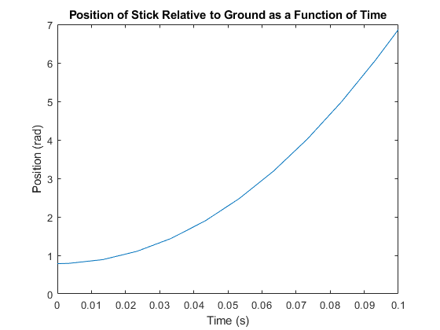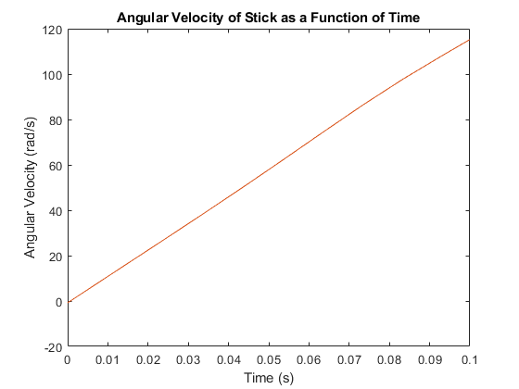

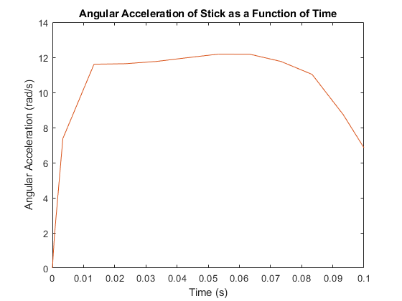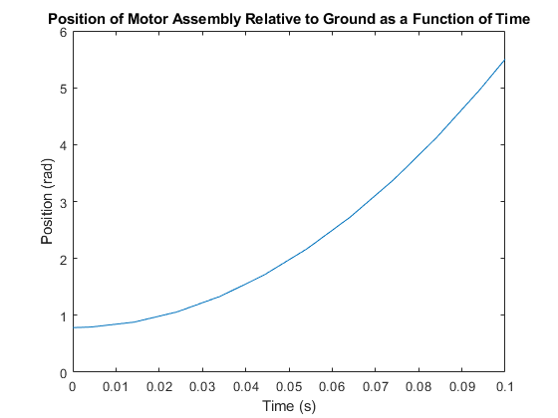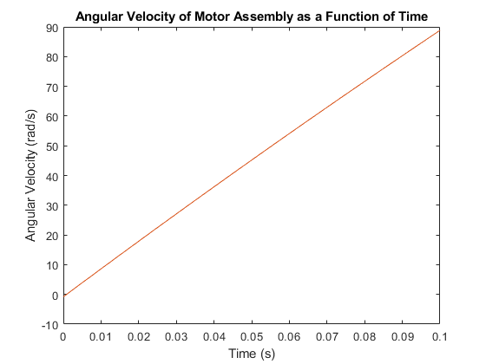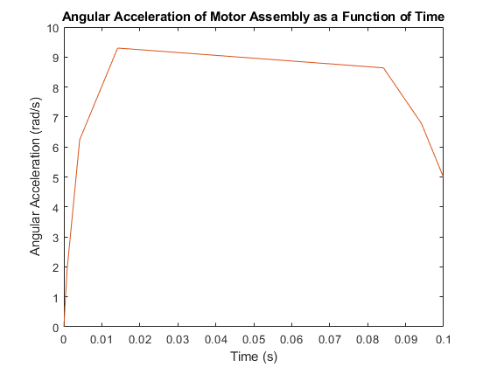

**Appendix B: Kollmorgen Quote**

